**2019-09-09**

**Real-Time ECL Calculator - Functional Specification (Phase 1)**

*prepared for*

|  |  |  |
| --- | --- | --- |
|  |  |  |

Table of Contents

Change Summary 4

Summary 6

Functional Flows 6

Instrument Coverage 7

Facility Drawdown Model 8

User Interface Design 8

Reporting Date Selection 24

Data Retention 24

Inputs 24

Borrower 24

Exposure 25

Loandepo 25

Facility 27

Security Position (TBC) 28

Repo (TBC) 29

Repayment Stage Details 31

Imported Cashflows 33

Collateral and Guarantee 34

CRM 36

Results 37

Scenario Weighting Logic 37

User Access Management 37

Collateral and BU Department Code 38

Simulation States 39

# Change Summary

|  |  |  |  |
| --- | --- | --- | --- |
| Modified By | Modified Date | Section | Modification |
| [Ozcay, Bilge](https://erswiki.analytics.moodys.net/display/~OzcayB) | 04 Nov 2019 | User Access Management | Added a matrix to clarify UAM |
| [Ozcay, Bilge](https://erswiki.analytics.moodys.net/display/~OzcayB) | 06 Nov 2019 | Curve Lookup | BEA indicated that reference curve lookup and discount curve lookup is not needed anymore.  Section removed. |
| [Ozcay, Bilge](https://erswiki.analytics.moodys.net/display/~OzcayB) | 06 Nov 2019 | CRM | Updated the Guarantee mockup to allow % or amount coverage. |
| [Ozcay, Bilge](https://erswiki.analytics.moodys.net/display/~OzcayB) | 11 Nov 2019 | Simulation States | Added simulation states section |
| [Lo Yuen San, Sandy (non-empl)](https://erswiki.analytics.moodys.net/display/~LoYuenSS) | 15 Nov 2019 | Various | * cosmetic change:   1) stage loan to repayment stage  2) Joint  to joint and several   * [Ozcay, Bilge](https://erswiki.analytics.moodys.net/display/~OzcayB) Change the checkbox to label to "Joint and Several". Replace the screen design in FSD.   3) corporate loan and corporate facility  4) ENTITY LEVEL to BORROWER LEVEL  5) End user to general user; super user to advance user   * specify: exposure and CRM can be edited * as of date should be selection of available data in RFO * specify: search support wild card * import and export cashflow * specify: entered information will be save before simulation * marked repo and security to TBC (phase 2) * deleted fields SOURCE SYSTEM, STAGING SOURCE, IMPORT SOURCE, SEGMENT TYPE in ENTITY * Clarified DIM_13,DIM_14 and DIM_15  in LOANDEPO * deleted field COUNTERPARTY _CODE  in LOANDEPO according to user request * deleted field FIRST_PAYMENT_DATE, USED_AMOUNT, MKT_SPREAD, MULT_SPREAD, RESET_REQUENCY, FIXING_RULE FIRST_FIXING_DATE, ACCRUAL_BASIS in FACILITY according to user request * [Lo Yuen San, Sandy (non-empl)](https://erswiki.analytics.moodys.net/display/~LoYuenSS) If you don't have MKT_SPREAD, you won't be able to model floating rate facility. Confirm all facilities will be fixed rate * [Lo Yuen San, Sandy (non-empl)](https://erswiki.analytics.moodys.net/display/~LoYuenSS) Without RESET_FREQUENCY, they won't be able to model a different reset frequency than interest frequency. Confirm all facilities will be fixed rate. Same may apply to FIXING_RULE. * [Lo Yuen San, Sandy (non-empl)](https://erswiki.analytics.moodys.net/display/~LoYuenSS) We need accrual_basis. Without accrual_basis, Facility will not work. * default SYNC_BEGIN_DATE as Y at Repayment Stage Details * CLARIFIED CONTRACT_TYPE AND CONTRACT_TYPE_CODE, JOINT at collateral and guarantee * revised allocate CRM based on EAD instead of nominal |

# Summary

Moody's Analytics implemented RiskConfidence (RCO) and RiskFoundation (RFO) at BEA to compute expected credit loss (ECL) based on IFRS9 accounting rules on a monthly basis.

In addition to the monthly process, BEA is looking for a software solution to compute ECL of a credit proposal on demand in pro-forma basis. The computation should leverage the existing RCO + RFO based IFRS9 infrastructure where possible.

The purpose of document is to explain the design of the of the on-demand ECL solution.

In phase 1, only covers corporate. In phase 2, securities, retail customers are also included.

# Functional Flows

At a high level, the user flow will be as follows:

Borrower selection

* Search for an existing borrower
* Select the existing borrower or create a new borrower
* For existing borrower, edit borrower characteristics such as rating

Exposures

* Load and edit existing exposures for a borrower (only for existing borrower)
* Enter simulated exposures for a borrower
* Enter imported cashflows for an exposure (existing or new exposure)
* Enter repayment stage for a loan exposure

CRM

* Load and edit existing CRM for a borrower (only for existing borrower)
* Load existing CRM allocation for a borrower (only for existing borrower)
* Enter new CRM for a borrower
* Run auto CRM allocation based on existing rules and processes defined in RFO
* Manually change CRM allocation amount for each exposure ↔ CRM pair

Simulation

* Enter remarks and submit a simulation
* See results of a simulation
* Export results of a simulated to CSV and PDF
* Delete results of a simulation
* Reload the simulation

# Instrument Coverage

Following type of exposures will be covered in the simulation:

* Corporate Loans (LOANDEPO table in RFO)
* Corporate Facilities (FACILITY table in RFO)
* Security positions (SECURITY_POSITION and SECURITY tables in RFO) TBC Phase 2
* Repo (REPO table in RFO). TBC Phase 2
* Retail loans, credit card and facilities
* Retail mortgages and facilities

Collateral and Guarantees: COLLATERAL, GUARANTEE and CONTRACT_GUARANTEE.

# Facility Drawdown Model

Same as IFRS9 production

To be remove Currently, BEA applies a simple model of 100% utilization on all the facilities, based on COA account name.

The simulated facilities should get the same model applied in ECL computation.

In order to achieve that, the existing parameter deal mapping will need to be slightly modified, so that the facility utilization model is applied based on table name, instead of COA account name.

# User Interface Design

## Simulation

Once user logs in to the real-time ECL tool, they can see the list of simulations they ran.

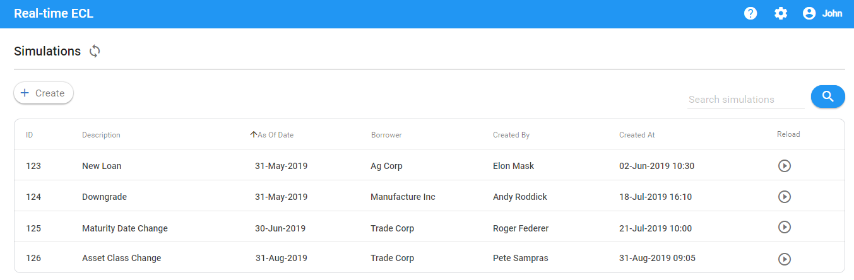

On this screen they can either create a new simulation from scratch or reload an existing simulation (including all stages of simulation) they ran before and reload it as a template.

User can search the past simulations based on the fields shown on UI.

Clicking on "Create" will bring a dialog to the user to enter the simulation description and select the as-of date.

As-of date is going to be defaulted to the latest one available in RFO. User can change to a past as-of date if needed, as long as as-of date is available in RFO as a reporting date.

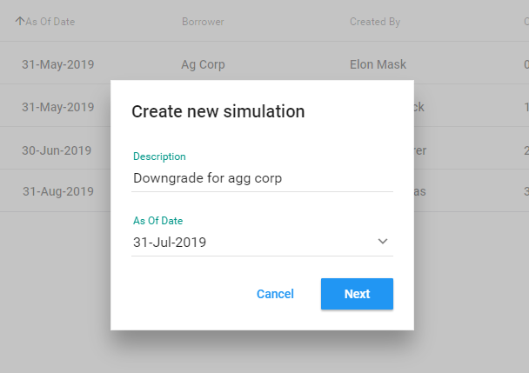

## Borrower

Clicking on Next will bring the Borrower search screen.

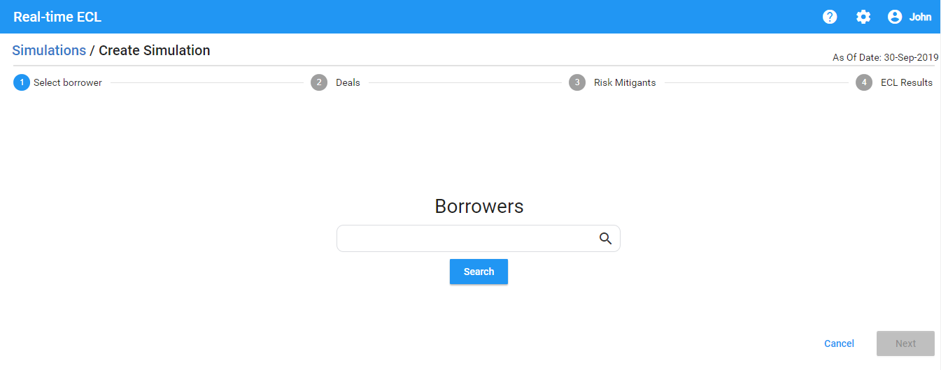

On this screen, user can enter keywords as wildcard and list of borrowers will be listed.

The keywords will be matched against the following borrower fields:

* Borrower name 1
* Borrower name 2 (Chinese character)
* Borrower ID
* CI Account Number
  + One borrower may have multiple CI Account Numbers. If the search matches at least one of the CI account numbers associated with the borrower, the borrower row will be shown.
  + Simulation always runs on borrower and not CI Account level.
  + If user is creating a new borrower, the CI Account Number will be empty

Once user hits the Search, the tool will bring the list of existing and simulated borrowers.

On this screen, user can do one of the following actions:

* Duplicate an existing or simulated borrower:
  + A dialog is shown to the user with all the borrower details.
  + User can change the attributes of the borrower and save.
  + Once saved, a new simulated borrower will be created with the values that the user edited.
  + The simulated entity will have a marker indicating that it is simulated

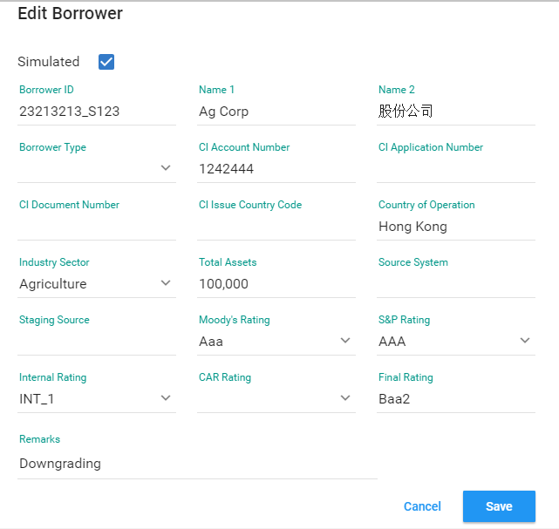

* Edit an existing borrower:
  + When user edits an existing borrower, the existing borrower is going to be grayed out and a new simulated borrower will be created with the values that the user edited.
  + The simulated entity will have a marker indicating that it is simulated
  + When user edits a simulated borrower, the values of the simulated borrower is overwritten
* Create a new borrower from scratch:
  + User will be given a dialog with list of all fields
  + User can fill each field
* Delete
  + User will have the option to delete a simulated borrower (existing borrowers cannot be deleted)

Following Table Summarizes the difference between a duplicate borrower action and edit borrower action:

|  |  |  |
| --- | --- | --- |
|  | Duplicate Borrower | Edit Borrower |
| Original borrower is grayed out on screen (applies to existing simulation and reload) | No | Yes |
| A new simulated borrower is created | Yes | Yes |
| Existing deals, CRM and CRM allocation for the borrower are associated with the new simulated borrower | Yes | Yes |
| When simulation is reloaded, user views the original borrower as grayed out | No | Yes |

## Deals

Selecting an entity and clicking on Next will bring the list of exposures associated with the borrower.

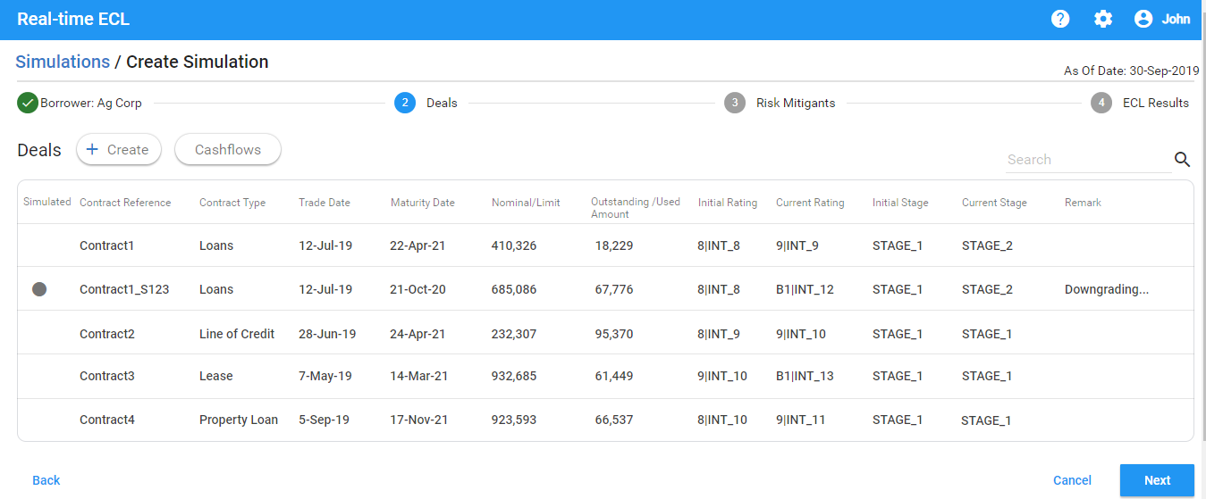

If this is an existing or duplicate borrower, then the existing exposures associated with the borrower will be shown on this screen.

For any new simulated borrower this screen will be empty.

The original currency amount and code, and the HKD equivalent should be shown.

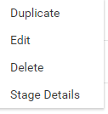

User can perform following actions on this screen:

* Duplicate an existing or simulated exposure
* Edit an existing or simulated exposure
  + Editing an existing exposure will create a copy of the exposure with the updated fields
  + Editing a simulated exposure will save the changes to the simulated exposure
* Delete a simulated exposure
* Create a simulated exposure from scratch
* Enter / edit repayment stage details for a simulated exposure
* Enter / edit imported cashflows for a simulated exposure (loandepo and security only)

Please note that cash flows or stage details cannot be imported or edited for existing deals.

Following Table Summarizes the difference between a duplicate deal action and edit deal action:

|  |  |  |
| --- | --- | --- |
|  | Duplicate Deal | Edit Deal |
| Original deal is grayed out on screen (applies to existing simulation and reload) | No | Yes |
| A new simulated deal is created | Yes | Yes |
| Existing imported cashflows and stage allocation is preserved | Yes (Copy cash flows and stages to the new simulated loan duplicated) | Yes (Copy cash flows and stages to the new simulated loan created) |
| When simulation is reloaded, user views the original deal as grayed out | No | Yes |

If user is creating a new simulated exposure from scratch, then user will be given a dialog to select:

* Instrument type
* A given template from the list of templates available matching the Instrument type
* A form of fields with the values coming from the template pre-populated

User selects the instrument type.

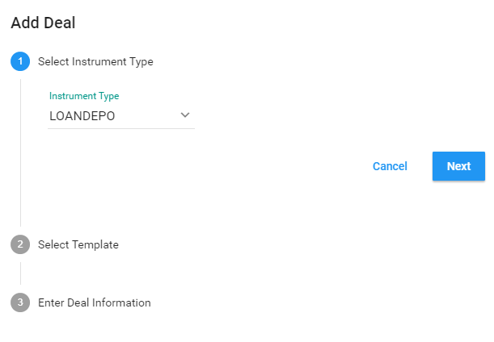

User selects a template.

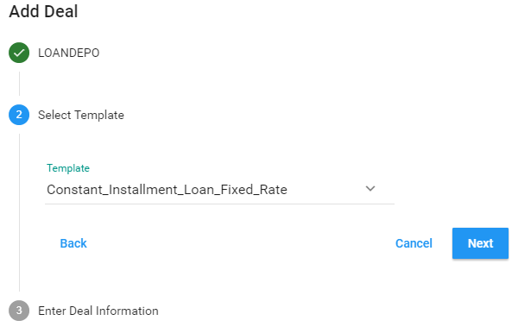

User updates / enters the deal characteristics.

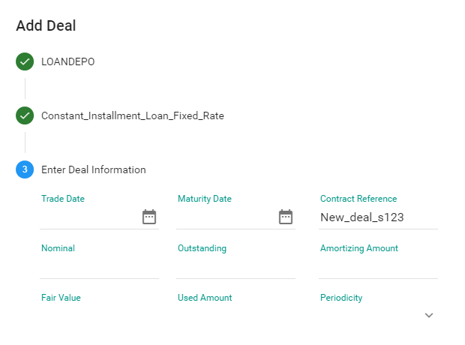

User clients on Save.

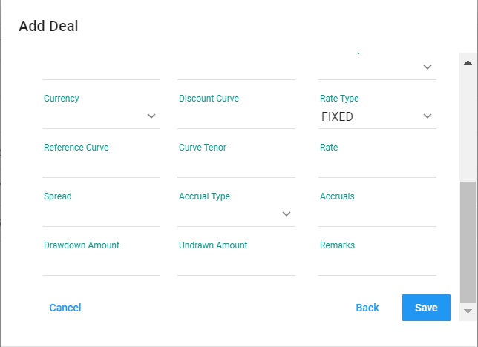

Once the user clicks Save, the new simulated exposure will be stored.

For a given simulated exposure, repayment stage details can be edited (loandepo only).

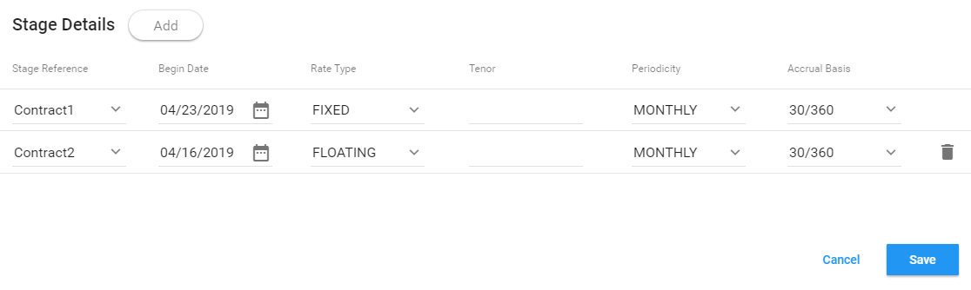

Also, for simulated exposures, user can enter imported cashflows (loandepo and security only).

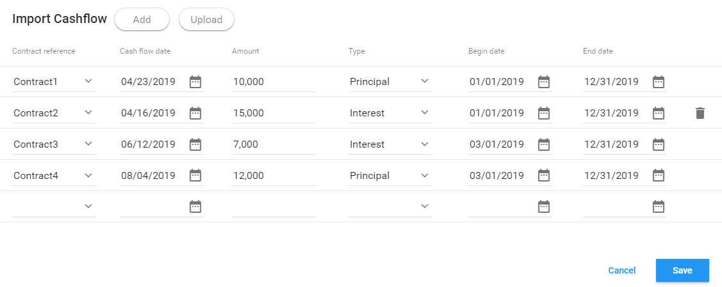

User has the option to add imported cashflows manually or upload in CSV format.

Once user saves the deal, Current Rating and Current Stage is computed and updated on the UI.



User has the ability to search deals by entering the keywords.

The keywords they entered will be checked against the deal attributes shown on the UI.

Once user finalizes the deal entry, user clicks Next. Tool takes the user to CRM allocation screen.

The original currency amount and code, and the HKD equivalent should be shown.

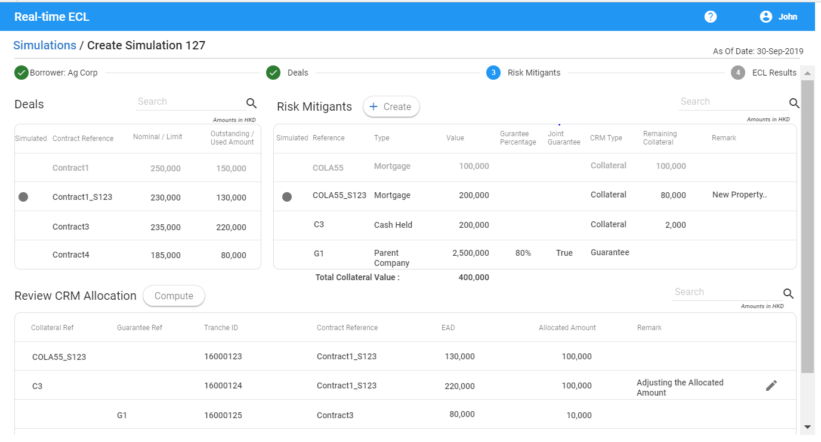

All amounts on this screen is shown in HKD as well as in the original currency; the original currency code should also be shown.

On this screen user can:

* View list of exposures (existing and simulated exposures entered earlier)
* View List of CRMs (existing and simulated)
* Enter a simulated CRM
* View list of existing and simulated CRM Allocation
* Enter a simulated CRM Allocation

## Risk Mitigant

User can add a Collateral or Guarantee by clicking on Create on Risk Mitigants panel.

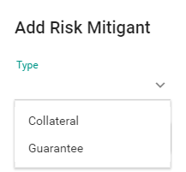

For Collateral, user then defines the fields.

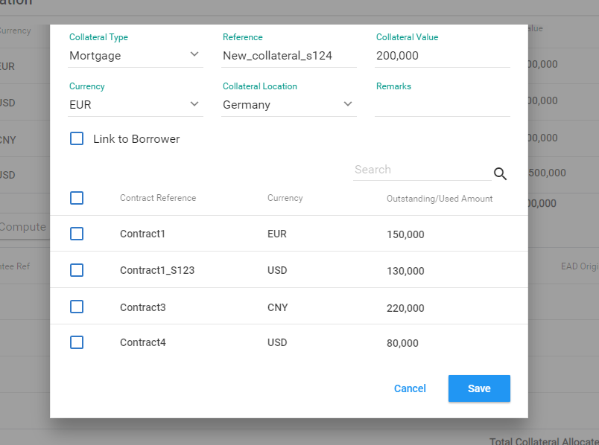

If link to borrower is selected, do not need to select related contract

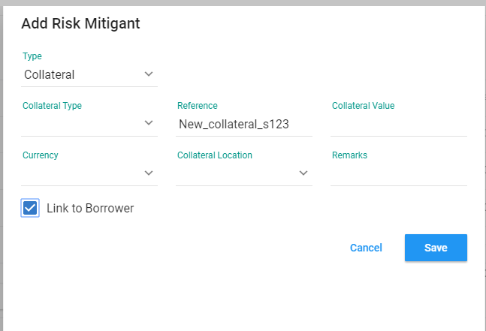

For Guarantee, user can define the fields.

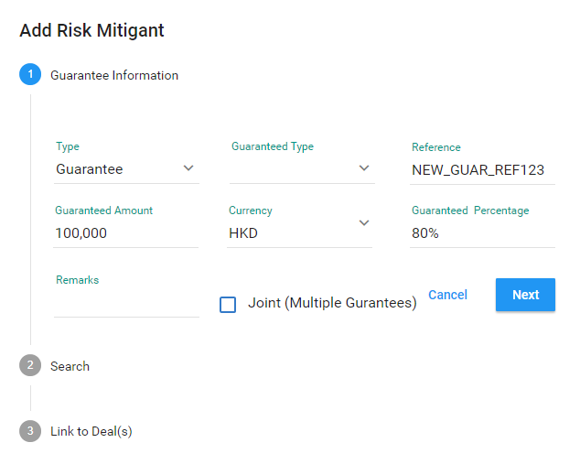

User will enter the CRM value in the native currency amount. Once the CRM is saved, the amount will be shown in HKD to the user in CRM summary screen.

For each Collateral, user will have an option to associate it at borrower level or individual deal level (but not both).

For Guarantees, user will have an option to associate it at individual deal level.

If no association is entered, collateral and guarantee will be distributed to the basket of deals in a prorata basis.

For Guarantees, user will have an option to define:

* Joint Guarantee: In this case, each guarantor will cover 100%
* Non-joint Guarantee: In this case, each guarantor will cover a portion (%) or amount of the exposure.

Once the CRM is defined, user can click on Compute button. This will allocate CRM to the exposures and user can view the allocation.

After CRM allocation is done, user has the option to change the allocated amount for each CRM allocation.

System will automatically compute the total collateral amount, allocated collateral amount and remaining (unallocated) collateral amount and show on the UI.

Once CRM entry and allocation is complete user can start the simulation.

Once the simulation is done, ECL results can be viewed.

If an exposure already exists in RFO, the results from the month end is pulled to compute:

* Initial Stage
* Initial ECL
* ECL Delta

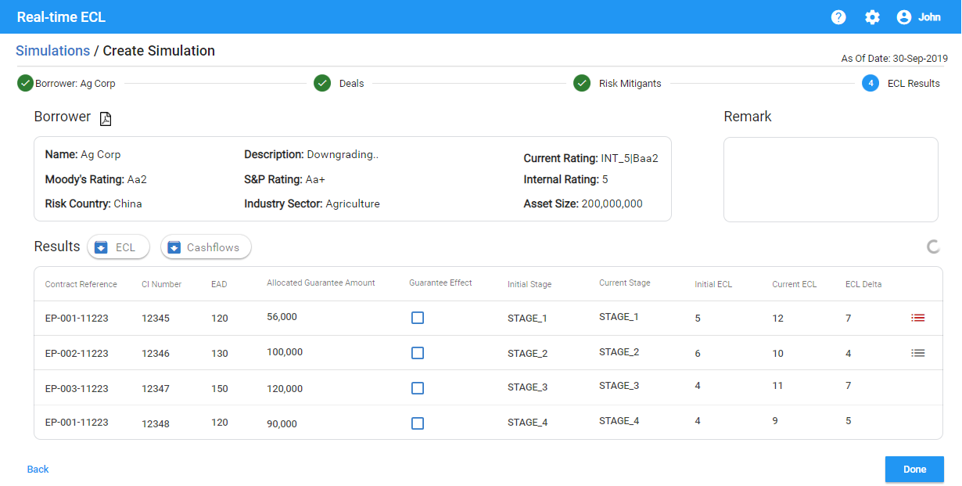

It should be marked clearly that all amounts are in HKD.

User can export the results to CSV or PDF.

User can also export the credit loss cashflows (same as production single-deal simulation).

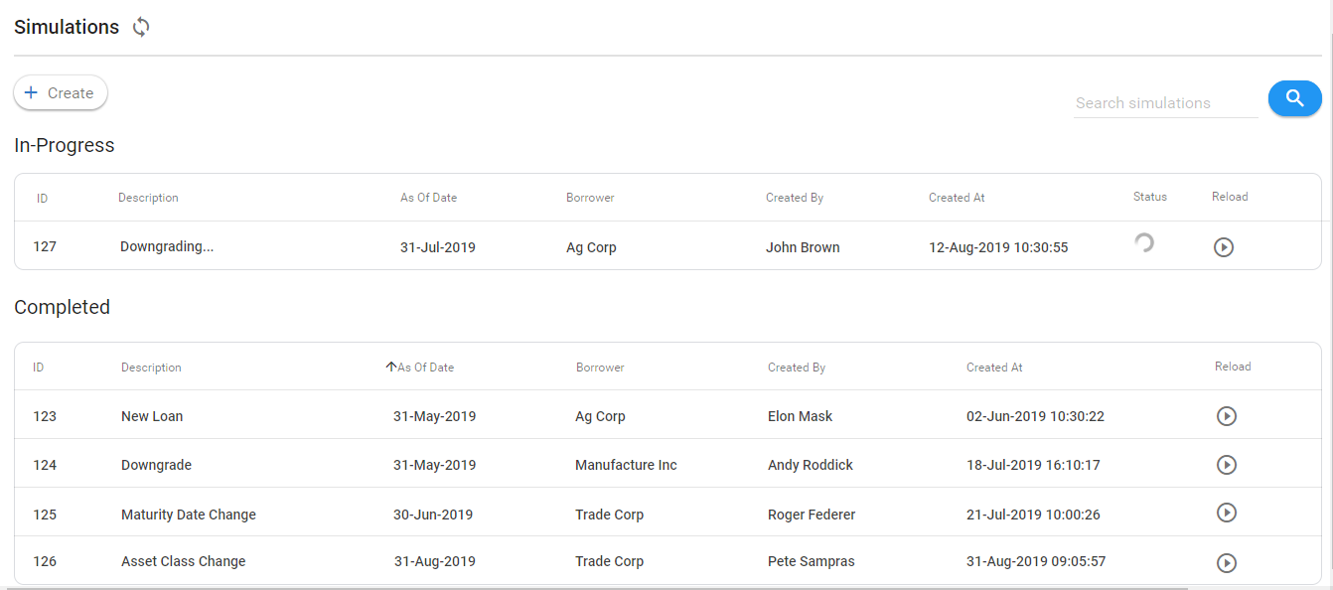

# Reporting Date Selection

The tool will automatically select the latest reporting date available for the simulation.

User can change it to a previous reporting date.

# Data Retention

Simulations results will only be available in the reporting date where they are produced.

Same rule applies to simulated borrowers, exposures, CRMs and CRM allocations created by the user.

# Inputs

This section summarizes all the fields that will show up on UI for each of the entry screens and their respective mappings to RiskFoundation data model.

## Borrower

|  |  |
| --- | --- |
| RFO Field | Display Value |
| as_of_date | As of Date |
| entity_code | Borrower ID |
| entity_desc | Name 1 |
| long_name | Name 2  (Chinese Characters) |
| type | type |
| country_of_operation | Country of Operations |
| ci_account_number | CI Account Number |
| ci_application_number | CI Application Number |
| ci_document_number | CI Document Number |
| ci_issue_country_name | CI Issue Country |
| industry_sector | Industry Sector |
| total_assets | Total assets |
| source_system | Source System |
| staging_source | Staging Source |
| moodys_rating | Moody's Rating |
| sp_rating | S&P Rating |
| car_rating | CAR Rating |
| internal_rating | Internal Rating |
| final_external_rating | Final External Rating |
| simulated | Simulated |
| remark | Remark |
| import_source | Import Source |

## Exposure

### Loandepo

[LOANDEPO Fields](https://erswiki.analytics.moodys.net/display/BRT/LOANDEPO+Fields)

|  |  |  |
| --- | --- | --- |
| RFO Field | Display Field | Comments |
| COUNTERPARTY_CODE | <not shown> |  |
| CONTRACT_REFERENCE | Contract Reference |  |
| CONTRACT_TYPE | Contract Type |  |
| BOOK_CODE | Dealbook | Will check the use in testing |
|  |  |  |
| DIM2 | Company Code |  |
| DIM13 | Segment Type |  |
| DIM14 | Current Rating |  |
| DIM15 | Final Rating |  |
| DIM20 | IFRS9 Stage |  |
| TRADE_DATE | Trade Date |  |
| VALUE_DATE | Value Date |  |
| MATURITY_DATE | Maturity Date |  |
| NOMINAL | Nominal |  |
| OUTSTANDING | Outstanding |  |
| RATE_TYPE | Interest Rate Type |  |
| RATE_VALUE | Interest Rate Value |  |
| PERIODICITY | Interest Periodicity |  |
| CURRENCY | Currency |  |
| CURVE_NAME | Repricing Curve | Show list of curves matching the deal currency. |
| TENOR | Repricing Tenor |  |
| CURVE | Curve | curve to select according to currency. curves will be available as per existing IFRS9 setup. |
| MKT_SPREAD | Repricing Spread |  |
| MULT_SPREAD | Repricing Spread Multiplier |  |
| FIXING_PERIODICITY | Repricing Periodicity |  |
| AMORTIZING_TYPE | Amortization Method |  |
| AMORTIZING_PERIODICITY | Amortization Periodicity |  |
| AMORTIZING_AMOUNT | Amortization Amount |  |
| DISCOUNT_CURVE_NAME | <not shown> | Show list of curves matching the deal currency. |
| ACCRUAL_BASIS | Accrual Basis |  |
| ACCRUALS | Interest Accruals |  |
| IMPORT_CF | Import Cashflows |  |

### Facility

[FACILITY Fields](https://erswiki.analytics.moodys.net/display/BRT/FACILITY+Fields)

|  |  |  |
| --- | --- | --- |
| RFO Field | Display Name | Comments |
| COUNTERPARTY_CODE | <not shown> |  |
| CONTRACT_REFERENCE | Contract Reference |  |
| CONTRACT_TYPE | Contract Type |  |
| BOOK_CODE | Dealbook |  |
| DIM2 | Company Code |  |
| DIM13 | Segment Type |  |
| DIM14 | Current Rating |  |
| DIM15 | Final Rating |  |
| DIM20 | IFRS9 Stage |  |
| TRADE_DATE | Trade Date |  |
| VALUE_DATE | Value Date |  |
| MATURITY_DATE | Maturity Date |  |
| AMOUNT | Limit Amount |  |
| AVAILABLE_AMOUNT | Available Amount |  |
| REVOLVING | Revolving |  |
| RATE_TYPE | Interest Rate Type |  |
| INTEREST_RATE | Interest Rate Value |  |
| FREQUENCY | Interest Periodicity |  |
| CURRENCY | Currency |  |
| CURVE_NAME | Repricing Curve Name | Show list of curves matching the deal currency. |
| Curve | Repricing curve | Show list of curves matching the deal currency. Curves will be available as per the current IFRS9 setup. |
| TENOR | Repricing Tenor |  |
| MKT_SPREAD | Repricing Spread |  |
| MULT_SPREAD | Repricing Spread Multiplier |  |
| RESET_FREQUENCY | Repricing Periodicity |  |
| DISCOUNT_CURVE_NAME | <not shown> | Show list of curves matching the deal currency. |
| ACCRUAL_BASIS | Accrual Basis | (follow basis currency) |
| ACCRUALS | Accruals |  |
| IMPORT_CF | Import Cashflows |  |

### Security Position (TBC)

[SECURITY_POSITION Fields](https://erswiki.analytics.moodys.net/display/BRT/SECURITY_POSITION+Fields)

|  |  |  |
| --- | --- | --- |
| RFO Field | Display Name | Comments |
| SECURITY_POSITION.CONTRACT_REFERENCE | Contract Reference |  |
| SECURITY_POSITION.SECURITY_REFERENCE | Security Reference |  |
| SECURITY_POSITION.CONTRACT_TYPE | Contract Type |  |
| SECURITY_POSITION.BOOK_CODE | Dealbook |  |
| SECURITY_POSITION.LONG_SHORT | <not shown> | Defaulted to "L". |
| SECURITY_POSITION.DIM2 | Company Code |  |
| SECURITY_POSITION.DIM13 | Segment Type |  |
| SECURITY_POSITION.DIM14 | Current Rating |  |
| SECURITY_POSITION.DIM15 | Final Rating |  |
| SECURITY_POSITION.DIM20 | IFRS9 Stage |  |
| SECURITY_POSITION.TRADE_DATE | Trade Date |  |
| SECURITY_POSITION.VALUE_DATE | Value Date |  |
| SECURITY_POSITION.NOMINAL | Number of Securities |  |
| SECURITY.SECURITY_REFERENCE | Security Reference |  |
| SECURITY.SECURITY_TYPE | Security Type |  |
| SECURITY.ISSUER_CODE | Issuer Code |  |
| SECURITY.CURRENCY | Currency |  |
| SECURITY.RATING_AGENCY_CODE | Rating Agency |  |
| SECURITY.RATING | Rating |  |
| SECURITY.ISSUE_DATE | Issue Date |  |
| SECURITY.MATURITY_DATE | Maturity Date |  |
| SECURITY.PRICE_INDICATOR | Price Indicator |  |
| SECURITY.BID_PRICE | Bid Price |  |
| SECURITY.OFFER_PRICE | Offer Price |  |
| SECURITY.UNITY_NOMINAL | Unity Nominal |  |
| SECURITY.RATE_TYPE | Interest Rate Type |  |
| SECURITY.COUPON_PERIODICITY | Interest Periodicity |  |
| SECURITY.RATE_VALUE | Interest Rate Value |  |
| SECURITY.CURVE_NAME | Repricing Curve | Show list of curves matching the deal currency. |
| Discount curve? |  |  |
| SECURITY.TENOR | Repricing Tenor |  |
| SECURITY.MKT_SPREAD | Repricing Spread |  |
| SECURITY.MULT_SPREAD | Repricing Spread Multiplier | Default to 1 for floating date |
| SECURITY.ACCRUED_INTEREST | Accruals |  |
| SECURITY.ACCRUAL_BASIS | Accrual Basis |  |
| SECURITY.AMORTIZING_TYPE | Amortization Method |  |
| SECURITY.AMORTIZING_PERIODICITY | Amortization Periodicity |  |
| SECURITY.AMORTIZING_AMOUNT | Amortization Amount |  |

### Repo (TBC)

In line with the existing design, user should enter collateral against the repo deal. The security entered as part of deal characteristics will not be used as collateral for repo.

|  |  |  |
| --- | --- | --- |
| RFO Field | Display Name | Comments |
| CONTRACT_REFERENCE | Contract Reference | Unique code that identifies the contract |
| REPO_TYPE | Repo Type | Type of repo transaction 'R' for repos 'RR' for reverse rep |
| BOOK_CODE | Book code | Identifier of the booking unit to which the transaction is linked. The deal_book is used at any level of consolidation to include a set of transactions in the scope of a calculation. |
| TRADE_DATE | Trade Date |  |
| VALUE_DATE | Value Date |  |
| MATURITY_DATE | Maturity Date |  |
| SECURITY_REFERENCE | Security Reference | Refence of the security on the security leg |
| SECURITY_NOMINAL | Security Nominal | Nominal of security leg. |
| CASH_NOMINAL | Cash Nominal |  |
| CASH_CURRENCY | Currency |  |
| CASH_INTEREST_RATE | Interest Rate |  |
| CASH_ACCRUAL_BASIS | Accrual Basis | Actual/365  Actual/360  Actual/Actual  30/360  30E/360  30A/360 |
| CASH_INITIAL_YEILD | Cash Initial Yeild | In % |
| CASH_AMORTIZED_COST | Amortized Cost |  |
| RISK_COUNTRY |  |  |
| CONTRACT_TYPE |  |  |
| DIM2 | Company Code |  |
| DIM6 | Basel Asset Class |  |
| DIM13 | Segment Type |  |
| DIM14 | Original Rating |  |
| DIM15 | Current Rating |  |
| RATE_DEF_TYPE | Rate type | Fixed or Floating FixFixed |
| TENOR | Tenor |  |
| NEXT_FIXING_DATE | Next Fixing Date | For cash legs with a floating-rate, first rate reset date after the reporting date |
| FIXING_PERIODICITY | Fixing Periodicity | For floating-rate deals, frequency at which the rate is reset. |
| FIXING_CURRENT_VALUE | Fixing current value | Express in percentage Express in per |

### Repayment Stage Details

|  |  |  |
| --- | --- | --- |
| RFO Field | Display Name | Comments |
| BASE_CONTRACT_REF | Contract Reference | Reference of the contract to associate a repayment stage to |
| STAGE_REFERENCE | Repayment Stage Reference | Reference of the repayment stage contract |
| BEGIN_DATE | Date | Begin date of the repayment stage |
| SYNC_BEGIN_DATE | Syn Date | Flag to indicate whether repayment stage begin date should be synchronized with coupon date of the previous repayment stage (Default to Y) |
| RATE_TYPE | Rate Type | Fixed or Floating |
| TENOR | Tenor | Required of rate type is floating |
| RATE_VALUE | Rate | Fixed rate in percentage |
| PERIODICITY | Periodicity | Interest payment frequency  A: annual/ S: semi-annual/ Q: quarterly/ M: monthly/ N: none (will further test N for stage bullet) |
| ACCRUAL_BASIS | Accrual Basis | Actual/365  Actual/360  Actual/Actual  30/360  30E/360  30A/360 |
| MULT_SPREAD | Multiplying spread | Multiplying market spread applied to the market rate (when floating or variable), default  value is 1 |
| MKT_SPREAD | Market Spread | Market spread applied to the market rate when Rate Type is FLOATING. The market spread is expressed in basis point. |
| CAP | Cap | For floating rate contract: maximum interest rate value. Expressed in   percentage. |
| FLOOR | Floor | For floating rate contract:  minimum interest rate value. Expressed in percentage. |
| FIXING_NB_DAYS | No. of BD | Number of business days between the rate fixing date and the coupon begin date (positive: number of   days after the coupon begin date; negative: number of days before the coupon   begin date). This field could leave empty |
| FIXING_PERIODICITY | Fixing Periodicity | Periodicity of rate re-fixing, ie with which the rate value is reset. |
| FIXING_NEXT_DATE | Fixing Next Date | Date of first rate reset. No rate reset takes place between value date and this date. Normal rate reset (according to reset parameters) resumes after this date. |
| FIXING_CURRENT_VALUE | Fixing Current Value | Interest rate value fixed at last fixing date. |
| AMORTIZING_AMOUNT | Amortizing Amount | Amortizing amount. Calculated by the engine if not filled. |
| AMORTIZING_PERIODICITY | Amortizing Periodicity | Periodicity   of the capital repayments. Must be greater than coupon periodicity (>=   PERIODICITY).     Possible values are:     0: None     1: Annual     2: Semi-annual     3: Quarterly     4: Monthly     Authorized values: 0,1,2,3,4. |
| AMORTIZING_PERIOD_TENOR | Amortizing Period Tenor | Amortizing frequency in tenor format [nnYnnMnnD] (example: 7D, 1M, 1Y2M10D). If you leave the field empty, the software uses the interest payment frequency tenor (preset setup). |
| FIXING_PERIOD_TENOR | Fixing Period Tenor | Rate reset frequency in tenor format [nnYnnMnnD] (example: 7D, 1M, 1Y2M10D). If you leave the field empty, the software uses the interest payment frequency tenor (preset setup). |
| PERIODICITY_TENOR | Periodicity Tenor | Interest payment frequency in tenor format [nnYnnMnnD] (example: 7D, 1M, 1Y2M10D). |

### Imported Cashflows

|  |  |  |
| --- | --- | --- |
| RFO Field | Display Name | Comments |
| CONTRACT_REFERENCE | Contract identification of the cash flows. | Unique code which identifies the contract generating the cash flow |
| CASH_FLOW_DATE | Maturity date | Date at which the cash flow occurs |
| CASH_FLOW_AMOUNT | Amount value | Amount of the cash flow |
| OUTSTANDING | Outstanding value | Outstanding nominal If left empty, the application will calculate it as the sum of imported nominal flows occurring after the cash flow. |
| CCY_CODE | Currency | Currency |
| CASH_FLOW_TYPE | Indicates if the CF is interest or capital | Indicates if the cash_flow is interest flow (I) or capital flow (N).  Default value: N |
| CASH_FLOW_QUALITY | Indicates that the CF is certain | Indicates whether the cash flow is :  C = certain (fixed rate) E = estimated (floating rate)  Default value: C |
| BEGIN_DATE | Begin Date | For interest flow: date at which the interest started to accrue. Required for interest.  For nominal flow: value date of the contract. |
| END_DATE | End Date | For interest cash flow: date at which the interest stopped accruing. Required for interest. If left empty, the application will replace it with cash_flow_date. |

### Collateral and Guarantee

Following table lists the fields that'll be shown on each screen:

* Risk Mitigants: The fields shown on CRM summary screen
* Collateral Record: Fields shown on the editable screen of Collateral
* Guarantee Record: Fields shown on the editable screen of Guarantee

|  |  |  |  |  |  |
| --- | --- | --- | --- | --- | --- |
| Column Name | Display Value  Risk Mitigants | Display Value  Collateral  Record | Display Value  Guarantee Record | RFO  Instrument  Table  COLLATERAL | RFO  Instrument  Table  GUARANTEE |
| beneficiary |  | Deal reference |  | BENEFICIARY | BENEFICIARY |
| borrower (4 treasurer) |  |  |  | borrower  use when link to borrower is selected | borrower  use when link to borrower is selected |
| contract_type | Description | Collateral Type | Guarantee Type | CONTRACT_TYPES.CT_DESC_USER  where CONTRACT_TYPE = CONTRACT_TYPES.CT_CODE_USER | CONTRACT_TYPES.CT_DESC_USER  where CONTRACT_TYPE = CONTRACT_TYPES.CT_CODE_USER  CONTRACT_TYPES.CT_DESC_USER  where CONTRACT_TYPE = CONTRACT_TYPES.CT_CODE_USER |
| contract_type_code | Contract Type Code |  |  | CONTRACT_TYPE | CONTRACT_TYPE |
| crm_type | CRM Type | Type | Type | 'COLLATERAL' | 'GUARANTEE' |
| crm_value_in_currency |  | Collateral Value | Guarantee Amount | Market Value | Market Value |
| currency |  | Currency | Currency | CURRENCY | CURRENCY |
| guarantee_percentage |  | Collateral  Percentage | Guarantee  Percentage | GUARANTEE_PERCENTAGE | GUARANTEE_PERCENTAGE |
| import_source |  |  |  | IMPORT_SOURCE | IMPORT_SOURCE |
| joint | Joint |  | Joint (Multiple Guarantees) | Hard code to 'F' | DIM20  (additional field for ECL calculator remark) |
| link_to_borrower |  | Link to Borrower | Link to Borrower | COLLATERAL_MODE | COLLATERAL_MODE |
| reference | Reference | Reference | Reference | CONTRACT_REFERENCE | CONTRACT_REFERENCE |
| remaining_collateral | Remaining Collateral |  |  | Left Join with PRICING_T_CDR value to get Remaining Collateral value. Applicable only to COLLATERAL Table. | Hard Code to 0 |
| remark | Remark | Remark | Remark | ATTRIBUTE_20 | ATTRIBUTE_9 |
| simulated | Simulated | Simulated | Simulated | 'T' if IMPORT_SOURCE = 'PRICING_SIMULATION' else 'F' | 'T' if IMPORT_SOURCE = 'PRICING_SIMULATION' else 'F' |
| value | Value |  |  | Join with MKT_FX_INPUT table and convert NOMINAL into HKD Currency | Join with MKT_FX_INPUT table and convert NOMINAL into HKD Currency |

# CRM

User will be able to allocate collateral and guarantees to the deals on a prorate basis based on the allocated EAD of the transaction.

Existing CRM allocation is going to be loaded to the system. After adding new entity, deals or CRM, user will be able to trigger an automatic CRM Allocation.

User can then change the allocation amount for each deal ↔ CRM pair.

User can associate a collateral to individual deals or at borrower level.

Deal level: User can manually select the list of deals the collateral is going to be allocated manually using check boxes.

Borrower level: User can check the entity level checkbox for the tool to automatically allocate collateral to all deals of the entity pro-rata basis.

User can define a joint or non-joint guarantee:

* Joint Guarantee: In this case, each guarantor will cover 100%
* Non-joint Guarantee: In this case, each guarantor will cover a portion (%) of the exposure. User can enter the coverage %.







# Results

## Scenario Weighting Logic

The tool will show results for individual scenarios for advance user as well as a scenario weighted result for both advance and general user.

The scenario weighting is going to use the existing weighting logic developed in ifrs9 production.

# User Access Management

The access to the exposures will be controlled with BU Department Code.

All RMs and advanced users will have access to all borrowers. However, BU Department Code will define the access to exposures and CRM.

There will be 2 types of BU Department Codes assigned to each user:

* Primary BU Department Code
* List of BU Department Codes

Each simulation will be associated with the primary BU Department Code.

There will be 2 types of users defined in the system:

* General user:
  + General user (loan officer) will have access to the deals and CRM that are associated to the list of BU Department Codes assigned to the general user.
  + Each general user will only have access to the simulations associated with the primary BU Department Code.
* Advanced user:
  + An advanced use will have access to all deals, CRM and simulation results.

Full details below:

|  |  |  |
| --- | --- | --- |
| Access | Advanced User | General User |
| Borrowers | All | All |
| Deals | All | Only deals associated with list of BU Dept Codes |
| CRM | All | Only CRM associated with the list of BU Dept Codes |
| Simulations | All | Only simulations associated with the **primary** BU Dept Code of the user |
| Export Credit Loss Cashflow Results | Yes | No |
| View Model ID Results (Deal Level) | Yes | No |
| View ECL Results of Non-Weighted Scenarios | Yes | No |
| View ECL Results of Weighted Scenarios | Yes | Yes |

## Collateral and BU Department Code

At BEA, a given collateral may be utilized by multiple departments, the logic of define by BU_DEPT and collateral distribution should follow ifrs9.

For example:

* RLD department extended $1m mortgage and the real estate collateral is now valued at $10m
* PBKD department can use $9m of collateral to originate another deal.

Although, there is only one piece of collateral, before feeding RFO, BEA is creating two collateral records:

* Collateral record 1: $1m associated with RLD loan
* Collateral record 2: $9m associated with PBKD loan

The BU department code is not tagged on the collateral. So the system should be finding the deal associated with the collateral, find the BU Department Code of the deal and use that in order to decide if the given user has access to the collateral or not.

In some cases (for example: Business development department), an end user may have access to more than one BU Department Codes. In that case, the pool of CRMs and deals associated with the list of BU Department codes should be brought up by the user during simulation for a given entity. CRM allocation is done for the pool of deals and CRM.

# Simulation States

A simulation can be in one of the following states:

* Draft: Simulation is created, but has not been submitted yet. An example could be a user selecting a borrower, entering deal and CRM, but leaving the tool before running the simulation.
* In Progress: Simulation is submitted to the ECL API but response has not been received yet.
* Completed: Simulation results have been received from the ECL API and stored
* Failed: Simulated is submitted to ECL API. Either an error has been received from the service or the request timed out.

Following table shows which action is available for each simulation state and behavior.

|  |  |  |
| --- | --- | --- |
|  | Open (by clicking on) Simulation | Reload Simulation |
| Draft | Brings user to Borrower Screen | Not available |
| In Progress | Not available | Brings user to Borrower Screen |
| Completed | Brings user to Results Screen | Brings user to Borrower Screen |
| Failed | Brings user to Results Screen | Brings user to Borrower Screen |